**=====================================================================================**

**PROJECT REPORT**

**Fantasy Cricket Team Prediction Application**

**=====================================================================================**

**A. SOFTWARES USED**

1. **Sublime Text**
2. **VS Code**
3. **Microsoft Excel**

**B. ABOUT THE SOFTWARE**

**a. Sublime Text**

**Sublime Text is a shareware cross platform source code editor with a Python application programming interface. It natively supports many programming languages and markup languages.**

**b. Visual Studio Code**

**Visual Studio Code is a free source-code editor made by Microsoft for Windows, Linux and macOS. Features include support for debugging, syntax highlighting, intelligent code completion, snippets, code refactoring, and embedded Git.**

**c. Spyder**

**Spyder is a powerful scientific environment written in Python, for Python, and designed by and for scientists, engineers and data analysts.**

**C. TECHNOLOGIES USED**

**a. WebScrapping**

**b. Django framework(Backend)**

**c. HTML, CSS, JavaScript**

**d. MongoDB**

**e. Git**

**D. ABOUT THE TECHNOLOGIES**

**a . Web Scraping (also termed Screen Scraping, Web Data Extraction, Web Harvesting etc.) is a technique employed to extract large amounts of data from websites whereby the data is extracted and saved to a local file in your computer or to a database in table (spreadsheet) format.**

**b. Django is a high-level Python Web framework that encourages rapid development and clean, pragmatic design. Built by experienced developers, it takes care of much of the hassle of Web development, so you can focus on writing your app without needing to reinvent the wheel. It’s free and open source.**

**Some of the the best features are :-**

**● Ridiculously fast : Django was designed to help developers take applications from concept to completion as quickly as possible.**

**● Reassuringly secure : Django takes security seriously and helps developers avoid many common security mistakes.**

**● Exceedingly scalable : Some of the busiest sites on the Web leverage Django’s ability to quickly and flexibly scale.**

**c. Hypertext Markup Language created by WHATWG is the standard markup language for documents designed to be displayed in a web browser. It can be assisted by technologies such as Cascading Style Sheets and scripting languages such as JavaScript.**

**Cascading Style Sheets is a style sheet language used for describing the presentation of a document written in a markup language such as HTML. CSS is a cornerstone technology of the World Wide Web.JavaScript, often abbreviated as JS, is a programming language that conforms to the ECMAScript specification.**

**JavaScript is high-level, often just-in-time compiled, and multi-paradigm. It has curly-bracket syntax, dynamic typing, prototype-based object-orientation, and first-class functions.**

**d. MongoDB**

**. Version: 4.4.1-signed**

**MongoDB is a cross-platform document-oriented database program. Classified as a NoSQL database program, MongoDB uses JSON-like documents with optional schemas. MongoDB is developed by MongoDB Inc. and licensed under the Server-Side Public License.**

**MongoDB provides high performance data persistence. In particular, support for embedded data models reduces I/O activity on database system and indexes support faster queries and can include keys from embedded documents and arrays.**

**e. Git is a free and open source distributed version control system designed to handle everything from small to very large projects with speed and efficiency.**

**E. Why is MONGODB SUITABLE FOR OUR PROJECT**

**In today world most famous nosql database is MongoDB. It is designed to meet the demands of modern apps with a technology foundation that enables you through:**

**• The Document data model – presenting you the best way to work with data.**

**• A distributed systems design – allowing you to intelligently put data where you want it.**

**• A unified experience that gives you the freedom to run anywhere – allowing you to future-proof your work and eliminate vendor lock-in.**

**It’s the best way to work with data in following aspects**

**• Easy - Work with data in a natural, intuitive way**

**• Fast – Get great performance without a lot work**

**• Flexible – Adapt and make changes quickly**

**• Versatile – Supports a wide variety of data and queries**

**It provides you the freedom to put data where you need it-**

**• Availability - Deliver globally resilient apps through sophisticated replication and self-healing recovery**

**• Scalability - Grow horizontally through native sharding**

**• Workload Isolation - Run operational and analytical workloads in the same cluster .**

* **Locality - Place data on specific devices and in specific geographies for governance, class of service, and low-latency access**

**It provides you the freedom to run anywhere**

**• Portability - Database that runs the same everywhere**

**• Cloud Agnostic - Leverage the benefits of a multi-cloud strategy with no lock-in**

**• Global coverage - Available as a service in 50+ regions across the major public cloud providers**

**With these capabilities, we can build an Intelligent Operational Data Platform, underpinned by MongoDB.**

**F. ABOUT THE PROJECT**

**Our project is for cricket enthusiastic people who love to play fantasy games like Dream11, MyTeam11, My11Circle,etc. By the use of the application one can check the efficiency of your premade team.**

**The selection criteria are according to the fantasy sports rule and constraints. Also in the application one has to register in the application and then can check the accuracy. MongoDB is used for storing the database like teams, batsmen, bowlers, allrounders, and wicket keepers.**

**--- DATABASE USED ---**

**The Database is taken from iplt20 official website with the help of web scraping. With the help of Beautiful Soup we extracted the following and added it into our MongoDB database-**

**a. Batsman**

**b. Bowlers**

**c. AllRounders**

**d. Wicketkeepers.**

**The above files contain the latest (updated) list of the players (considering the year 2020).**

**--- WORKING ---**

**In the application first the user has to register then only he/she can proceed to check their team accuracy. After registering their data is stored and can be viewed by only the super user. First we have to select two teams and then from the dropdown menu one can select the players from the selected teams. Our application creates its own team for comparison. The algorithm used to select our own team is self made. Parameters Considered For**

**Bowlers : Economy, Average and Strike rate**

**Batsman : Average and Strike- rate**

**All rounders : Bowling and Batting percent rank.**

**Formula for bowler:**

**pow(df['EcoBall'],2/3)*pow(df['AvgBall'],1/3)*pow(df['SrBall'],1/3)**

**Formula for batsmen:**

**pow(df['Avg'],3/5)*pow(df['Sr'],2/5)**

**Formula for allrounder:**

**pow(df['Batting_Rank'],3/4)*pow(df['Bowling_Rank'],1/4)**

**\*\*\* Here, bowler rank and batsman rank denotes the percent rank among their list, which is calculated in excel.\*\*\***

**--- 8 STEPS TO PREDICT YOUR 11 ---**

**1.Register by Making Your Account**

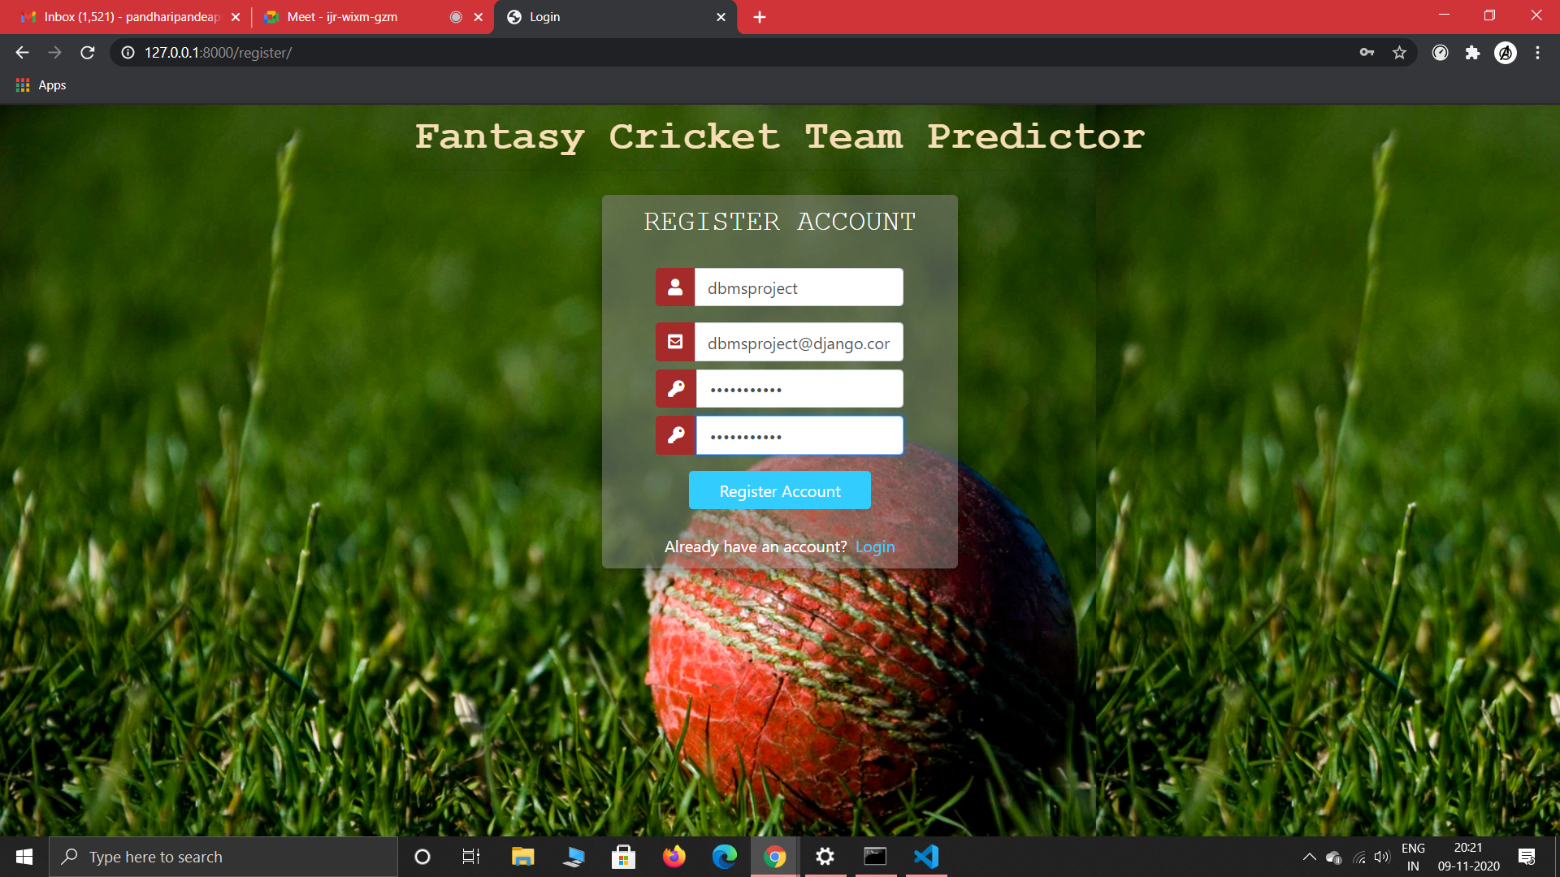

**2.Login Into Your Account**

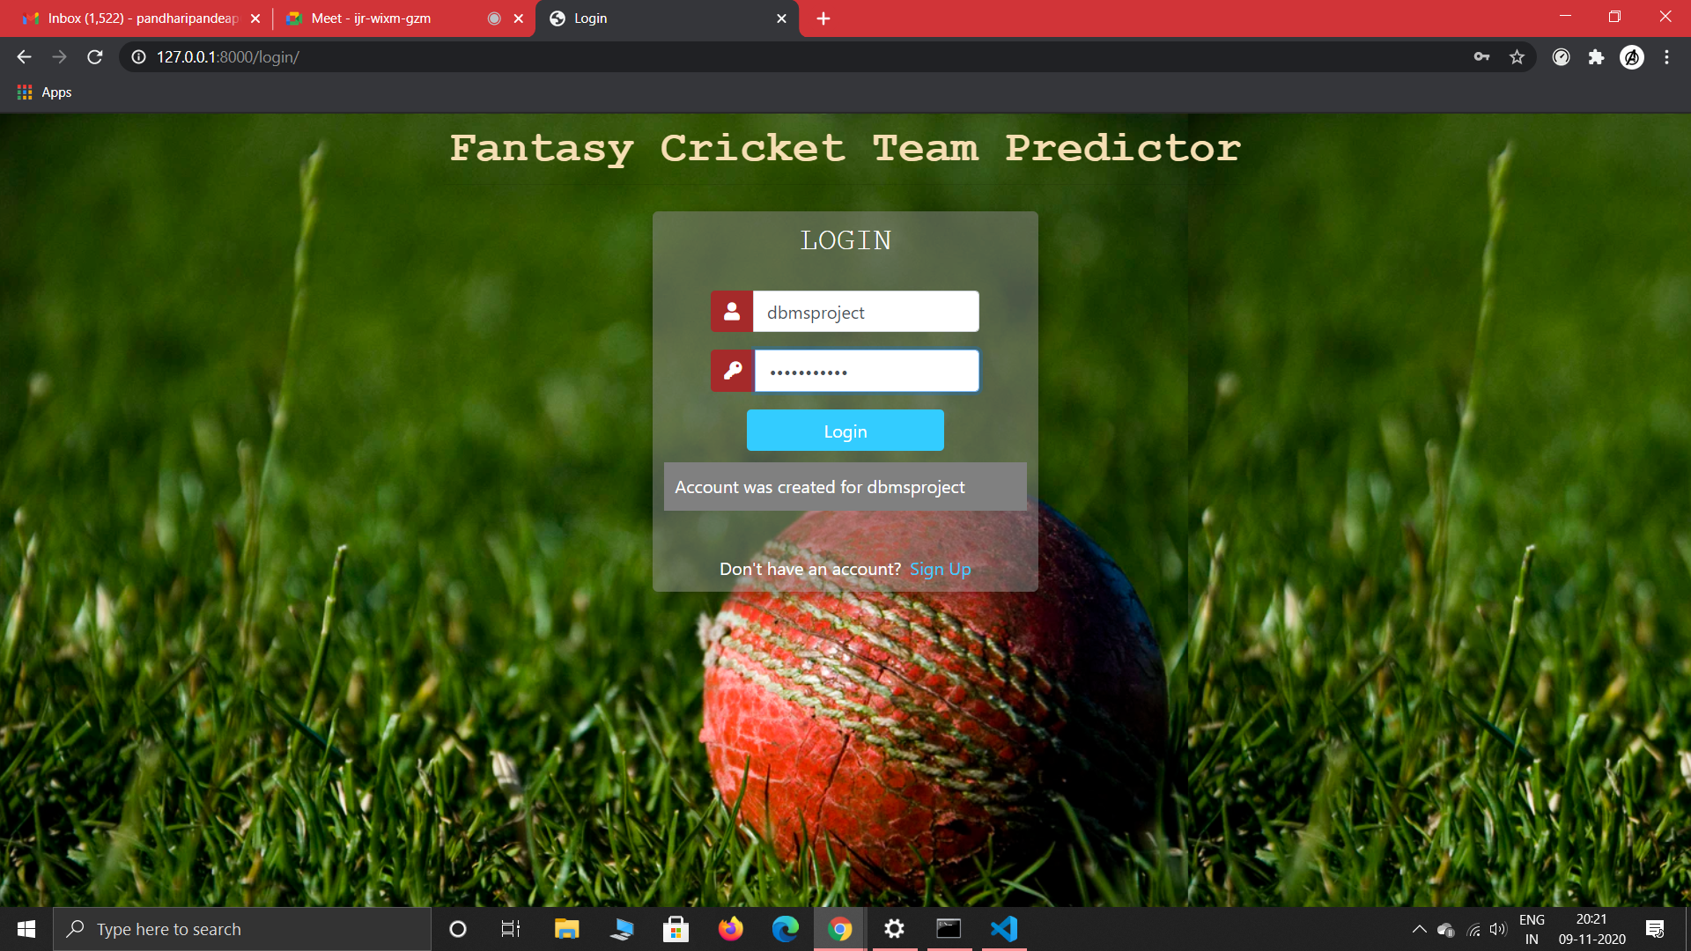

**3.Select Two Teams To Make Your Team Now**

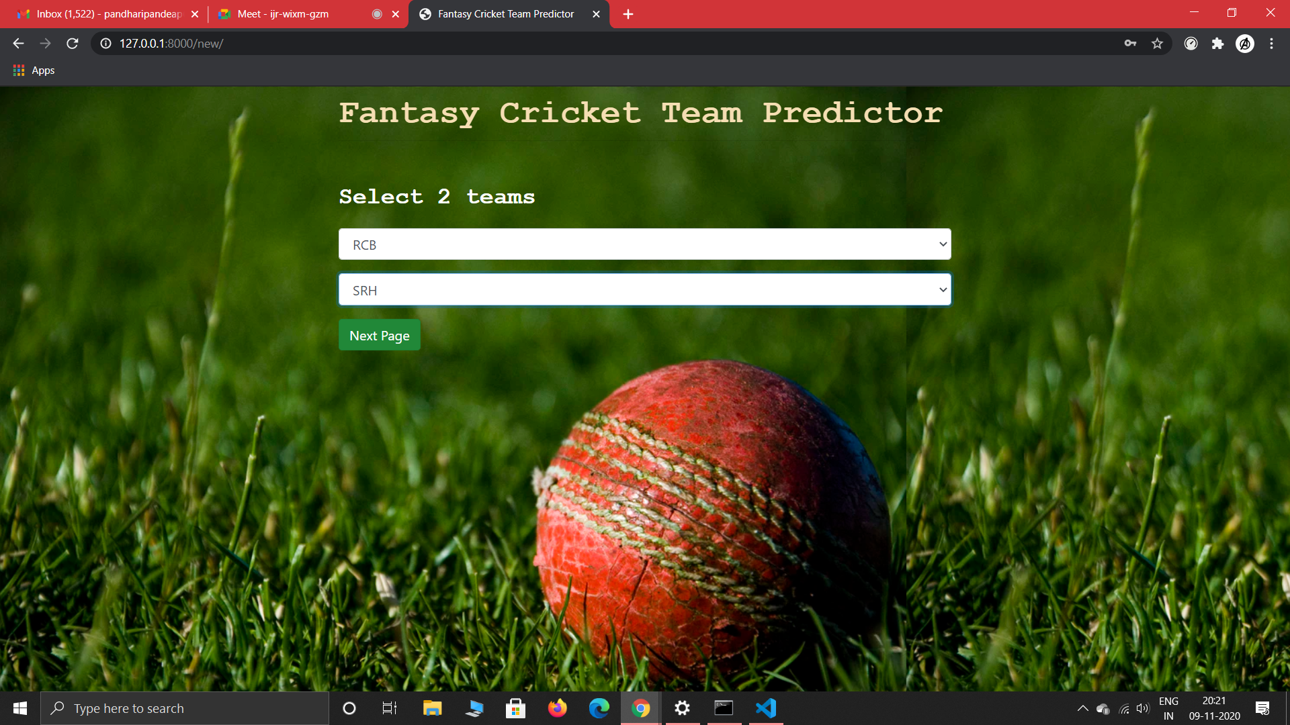

**4.Select the WicketKeepers for your 11**

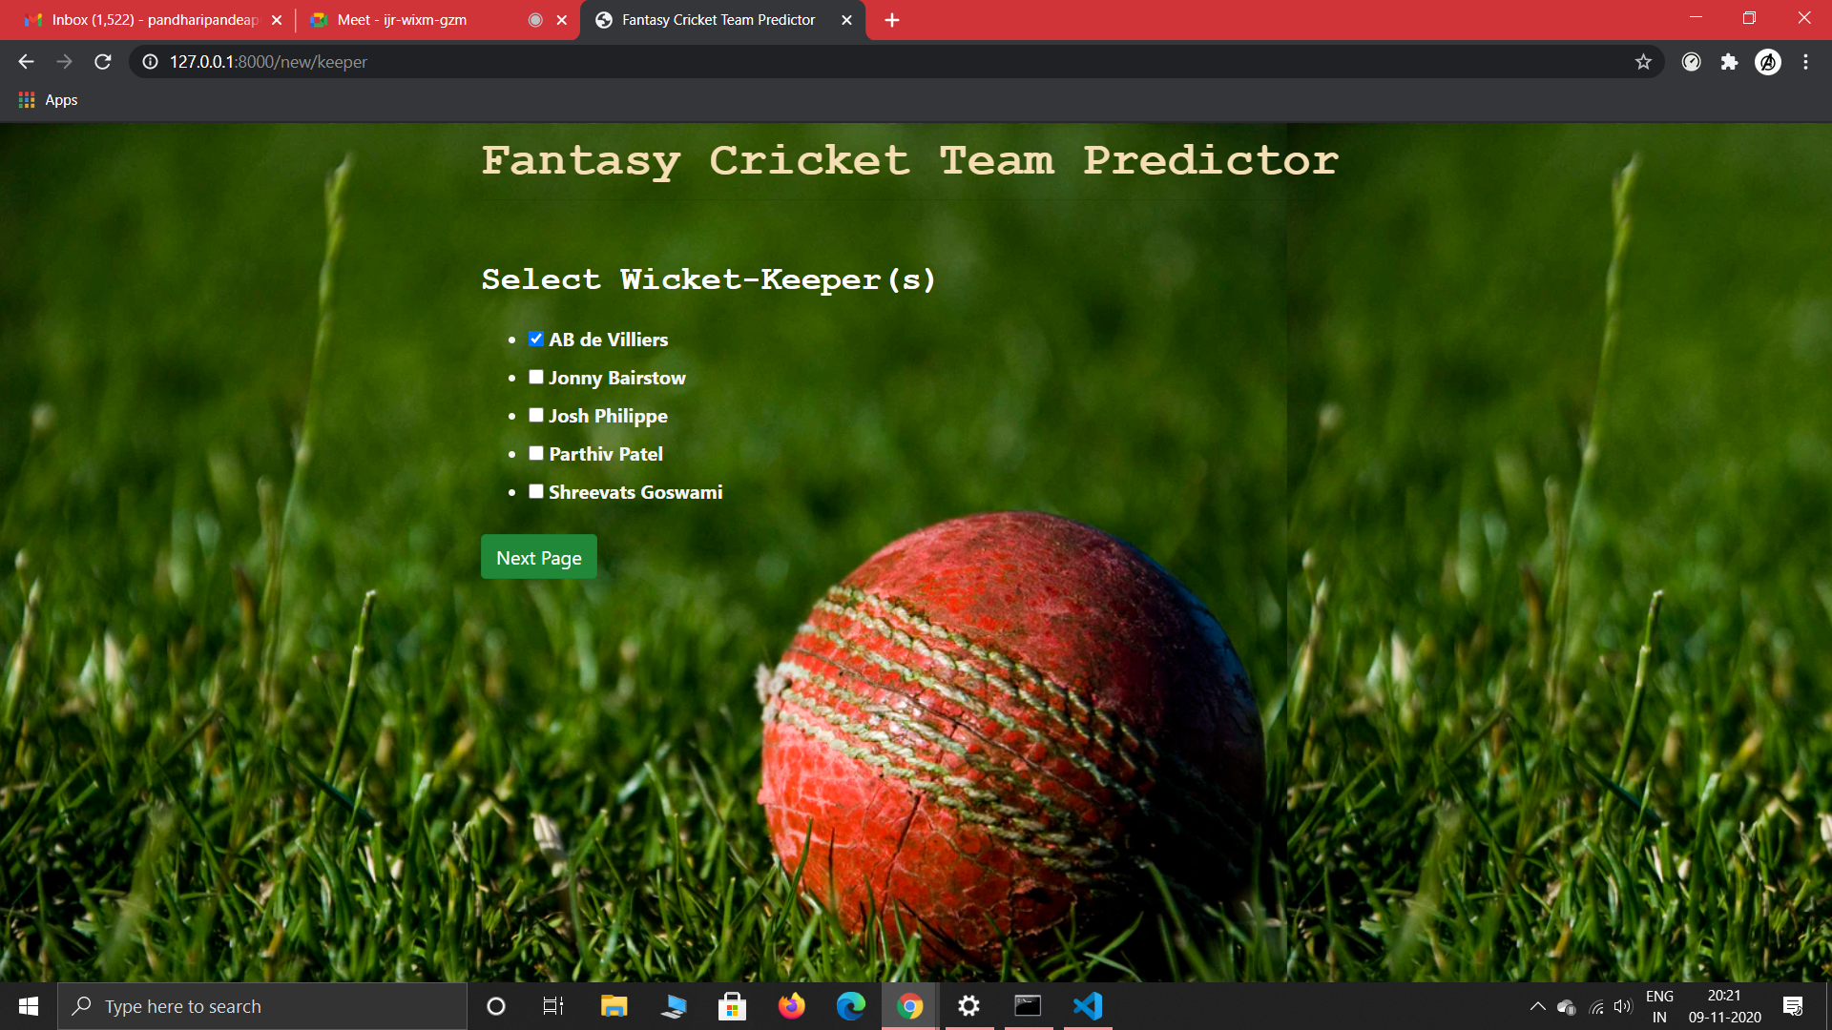

**5.Select the Batsmen for your 11**

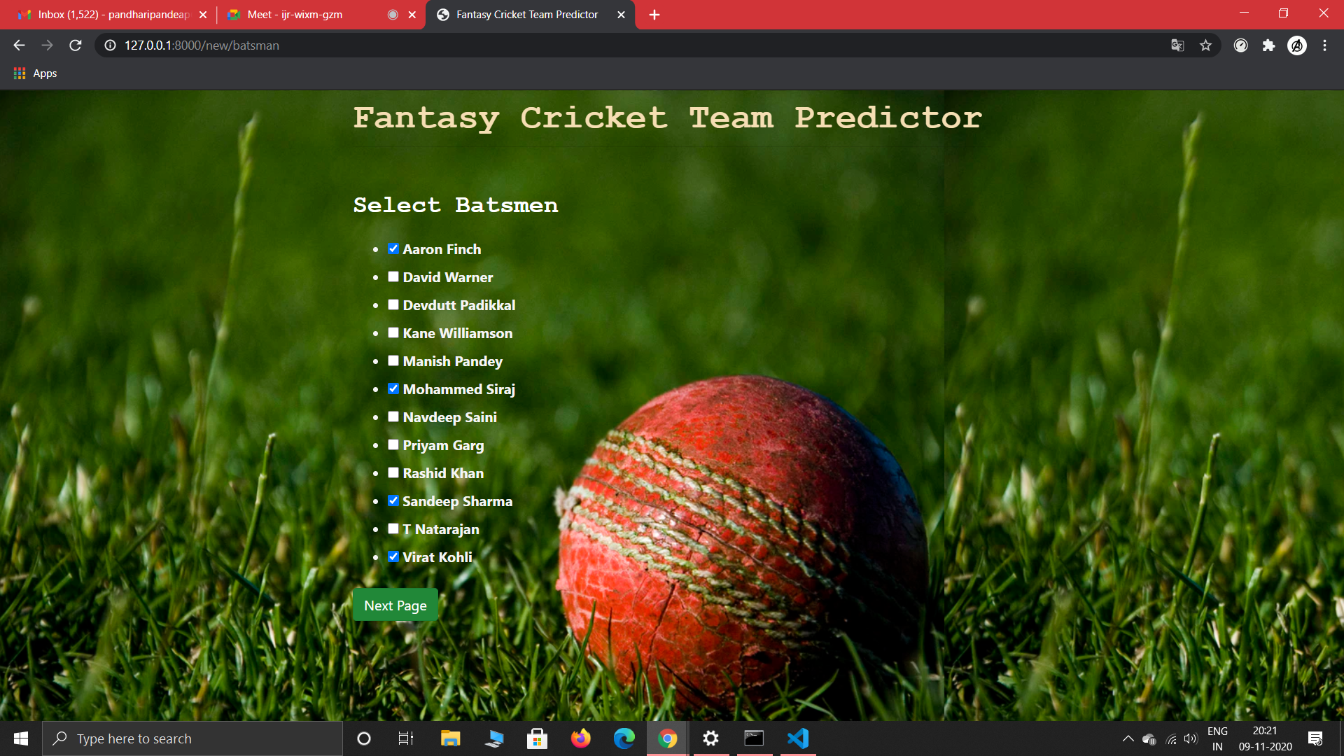

**6.Select the AllRounders for your 11**

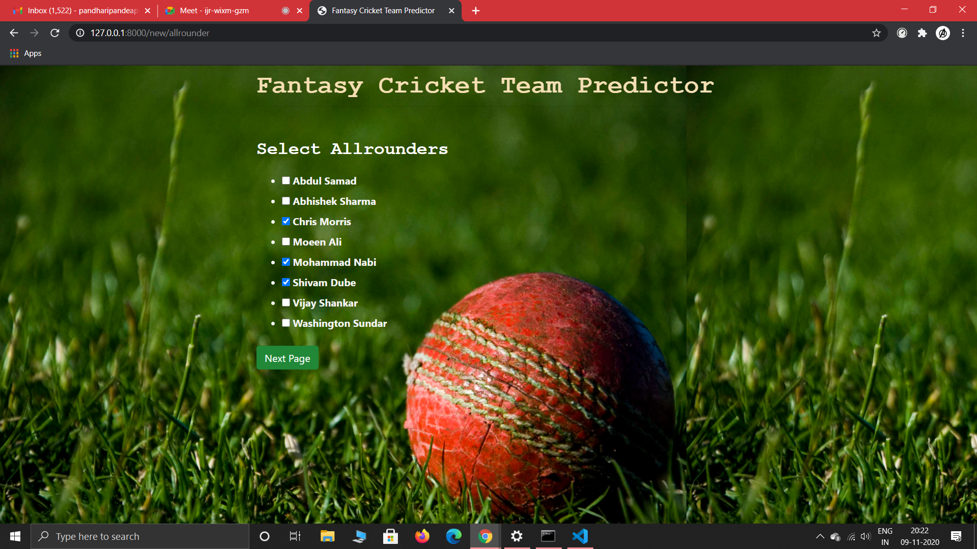

**7.Select the Bowlers for your 11**

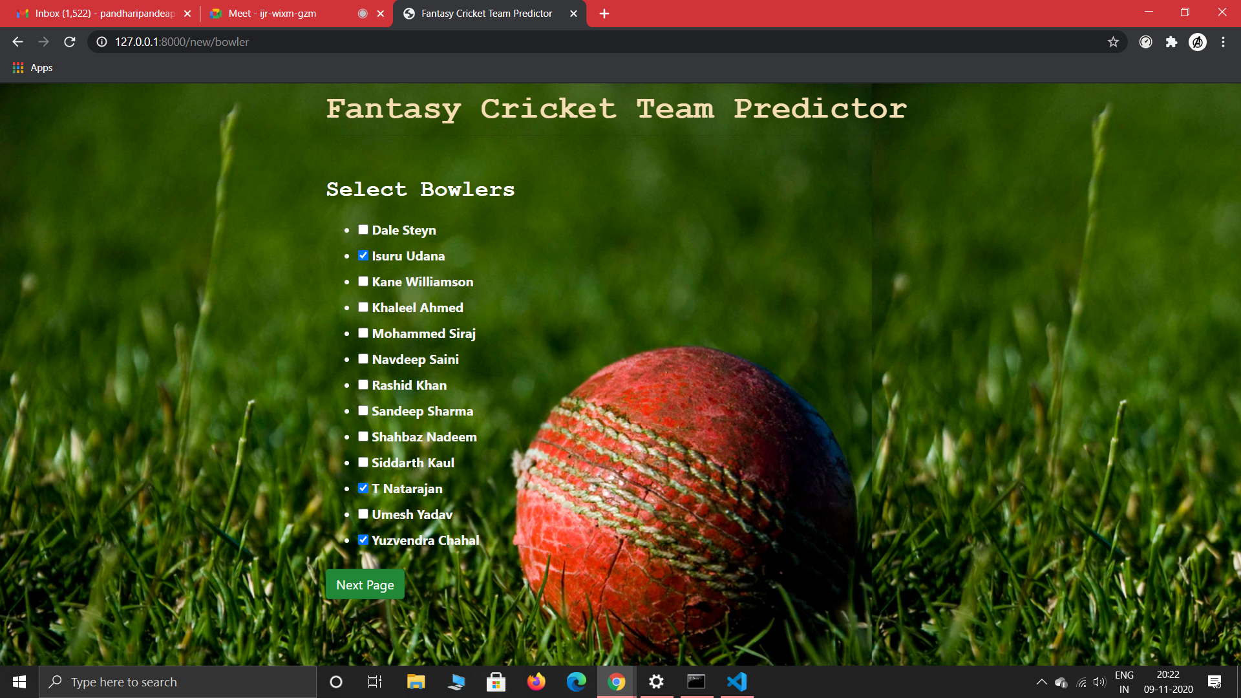

**8. Your Selected Team and It’s Prediction**

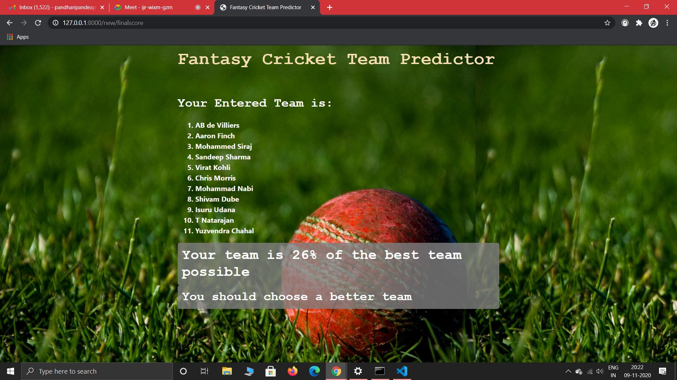

**--- FUTURE SCOPE ---**

**● This project can be further extended by adding live cricket score and tracking live fantasy score using REST API.**

**● We can further add many more functionality which will make this project much more convenient to use.**

**=============================================================================**

**Authors**

**1. Aryan Pandharipande[38]**

**2. Atharva Paliwal [40]**

**3. Chaitanya Kapre [42]**

**Github Repository**

[**https://github.com/pikachua7/Fantasy-Cricket-Team-Prediction**](https://github.com/pikachua7/Fantasy-Cricket-Team-Prediction)

**=============================================================================**